
2017 Year 12 PHYSICS ATAR

Semester 1

Task 6: Test 1

TASK TYPE: Test

CONTENT: Vectors, Forces and Projectile Motion – 5%

 | Possible Marks | Your Mark
Total | 45
Percentage | 100%

Student Name: ____________________________________

Date: ____________________________________

Teacher: J. Wijaya

Instruction:

- Answer all questions.

- All numeric answers are to be corrected to three significant figures unless specified.

- The air rifles for the “duck shooting” at a fun fair fire the pellets at 30.0 ms⁻¹. A girl fires the rifle at a duck 5.00 m away. She aims horizontally (at point (0,0), origin) at the “duck” which moves sideways at 0.500 ms⁻¹. Ignore air resistance.

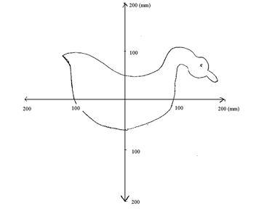
  - How long does the pellet take to reach the duck? [2]

Answer: ________________________

  - How far below origin will the girl’s pellet hit? Show your calculations. [4]

Answer: ________________________

  - Calculate the horizontal distance from the origin that this girl’s will hit. Write the answer in the space provided. [3]

Answer: ________________________ Left / Right (circle the correct answer) to the origin.

- Marvin takes 15.0 minutes to paddle his canoe 500 m (West to the opposite of the bank) in still water.

  - Calculate Marvin’s velocity.
[2]

Answer: ______________________________ Direction: ___________________________

After 15.0 minutes, Marvin returns to the opposite direction with the same speed. This time, due to the strong wind, the river flows at 3.00 m s⁻¹ to the south.

  - Draw a vector diagram to show the motion of going back, showing the net velocity. Give appropriate labels.
[2]

  - Calculate the net velocity.
[3]

Answer: ______________________________ Direction: ___________________________

- A car enters an intersection at 20.0 m s⁻¹ to the North where it collides with a truck. The impact rotates the car 90.0° clockwise and gives it a speed of 15.0 m s⁻¹.

  - Use the space below, using appropriate vectors to show the change of velocity of the car.
[2]

  - Calculate the change of velocity. Include direction.
[4]

Answer: ______________________________ Direction: ___________________________

- The diagram below shows a ball is rolling down a hill and accelerates. Ignore friction.

  - On the diagram below, with the reference to the ball, show all forces including the net force.
[3]

  - If the mass of the ball is 60.0 kg and the incline is 15.0º, calculate magnitude the net force acting on the ball.
[3]

Answer: ______________________________

  - Explain if this motion relates to the Newton’s first law of motion.
[2]

- A cannon is projected at 37.0º at 65.0 m s⁻¹ at the 125 m cliff. On the diagram below, it shows the position of the cannon at a certain time.
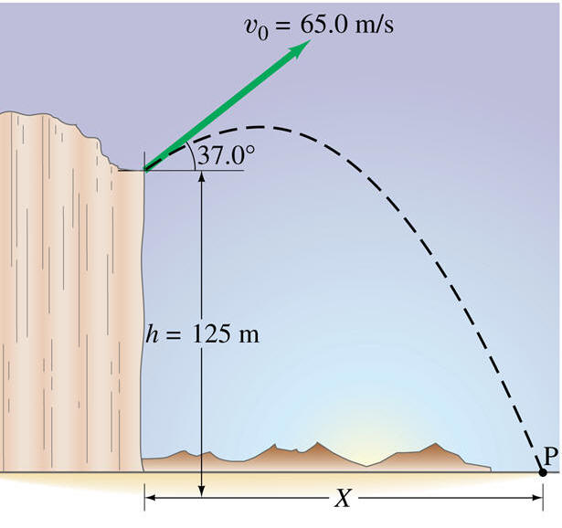
  - On the diagram,
[2]
    - Use letter W to show the net force of the cannon.

    - Use letter V to show the instantaneous velocity of the cannon.

  - Use the information to calculate the horizontal distance that the cannon can reach. [6]

Answer: ______________________________

  - A skateboarder at a skate park rides along the path shown in the diagram below. If the speed of the skateboarder at point A is 1.30 m s⁻¹, what is her speed at point B? Assume that friction is negligible.
[4]

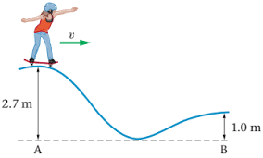

[Reference https://www.physicsforums.com/threads/find-final-speed-using-mechanical-energy-formula.893415]

Answer: ______________________________

  - If the skater rides from the top of the path (with the height of h metres) from rest, prove that the speed at the bottom of the path is:
[3]
$$v_{bottom}=\sqrt{2gh}$$

End of the Test

